T1.

<!DOCTYPE html>

<html lang="en">

<head>

<meta charset="UTF-8">

<meta name="viewport" content="width=device-width, initial-scale=1.0">

<style>

ul li:nth-child(even) {

background-color: rgb(173, 216, 230);

}

</style>

<title>Country List</title>

</head>

<body>

<ul>

<li>Eswatini</li>

<li>Ecuador</li>

<li>Tanzania</li>

<li>Spain</li>

<li>Slovakia</li>

<li>Iraq</li>

</ul>

</body>

</html>

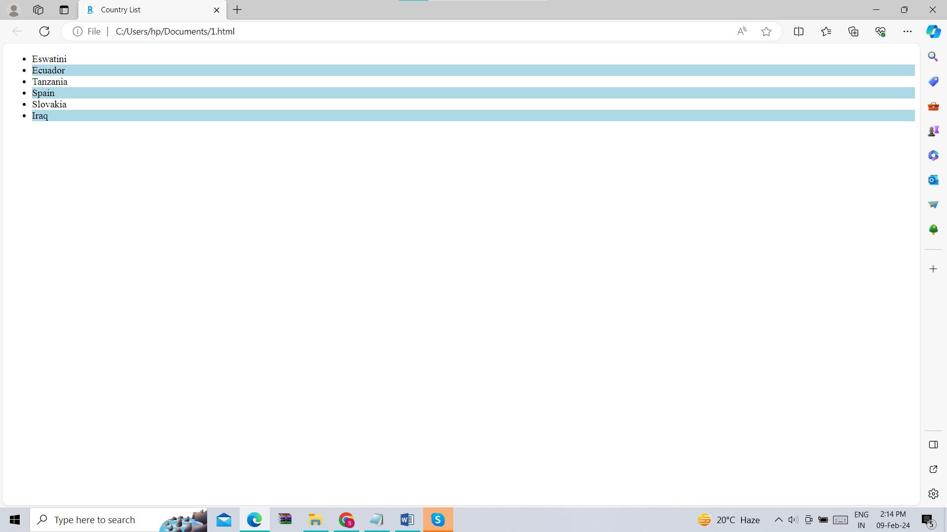

T2.

<!DOCTYPE html>

<html lang="en">

<head>

<meta charset="UTF-8">

<meta name="viewport" content="width=device-width, initial-scale=1.0">

<style>

table {

font-family: 'Arial', sans-serif;

border-collapse: collapse;

width: 100%;

}

th, td {

padding: 10px;

text-align: left;

border-bottom: 1px solid #ddd;

}

tr:nth-child(odd) {

background-color: #f2f2f2;

}

th {

background-color: #000;

color: #fff;

font-size: 14px;

}

</style>

<title>Diverse Table</title>

</head>

<body>

<table>

<tr>

<th>Country</th>

<th>Capital</th>

<th>Language</th>

</tr>

<tr>

<td>Albania</td>

<td>Tirana</td>

<td>Albanian</td>

</tr>

<tr>

<td>Papua New Guinea</td>

<td>Port Moresby</td>

<td>English</td>

</tr>

<tr>

<td>Latvia</td>

<td>Riga</td>

<td>Latvian</td>

</tr>

<tr>

<td>France</td>

<td>Paris</td>

<td>French</td>

</tr>

</table>

</body>

</html>

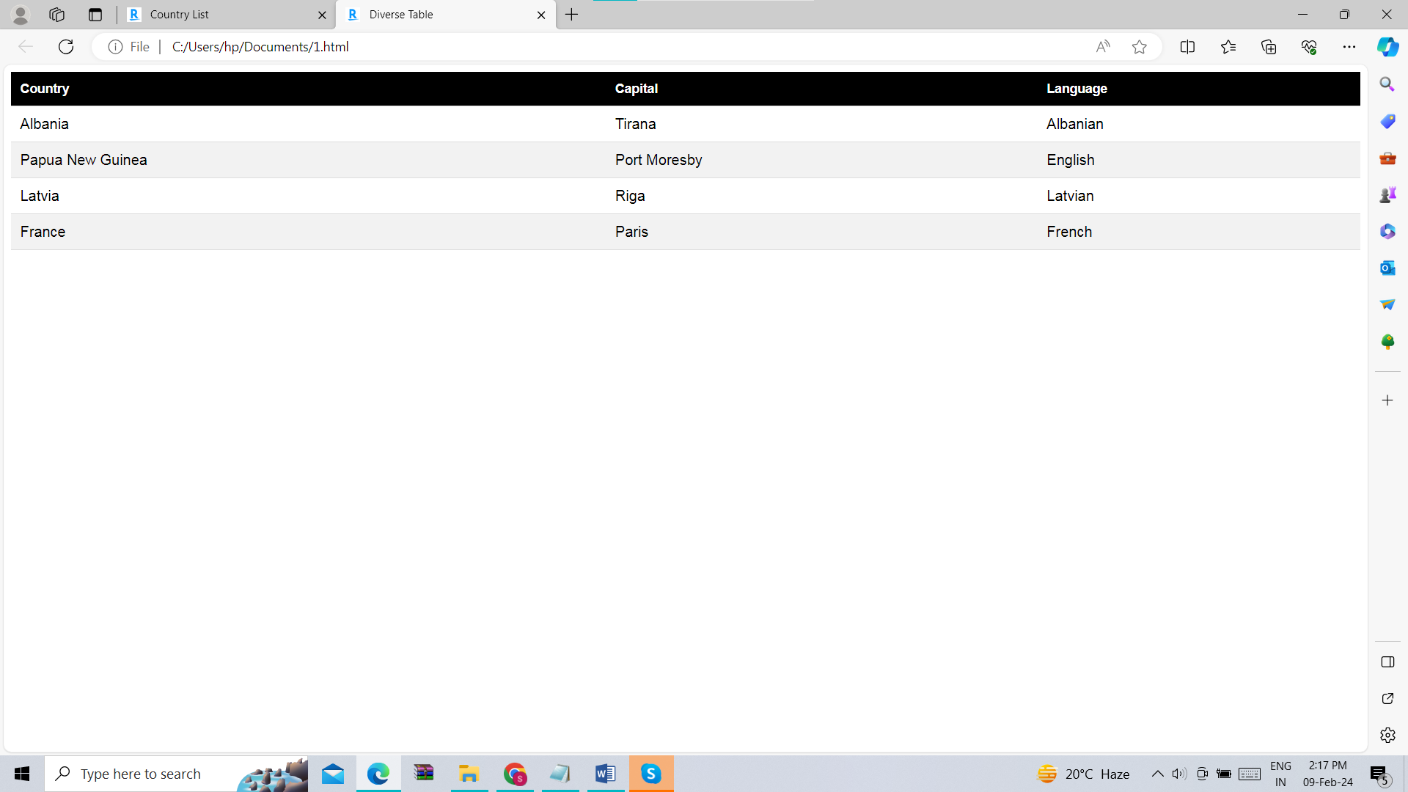

T3.

<!DOCTYPE html>

<html lang="en">

<head>

<meta charset="UTF-8">

<meta name="viewport" content="width=device-width, initial-scale=1.0">

<style>

body {

font-family: 'Arial', sans-serif;

padding: 20px;

}

h1 {

font-family: 'Roboto', sans-serif;

color: #333;

}

ul {

list-style: none;

padding: 0;

}

.meat {

background-color: #ff0000;

}

.vegetable {

background-color: #90EE90;

}

.dairy {

background-color: #FFFF00;

}

h2 {

font-style: italic;

color: #555;

}

</style>

<title>Recipe of Grilled Cheese Sandwich by Shangana</title>

</head>

<body>

<h1>Grilled Cheese Sandwich with Bacon and Tomato</h1>

<h2>Ingredients:</h2>

<ul>

<li class="meat">Bacon</li>

<li class="dairy">Cheddar Cheese</li>

<li class="dairy">Butter</li>

<li class="vegetable">Tomato</li>

<li class="dairy">Sliced Bread</li>

</ul>

<h2>Instructions:</h2>

<p>

We start by cooking the bacon until it's crispy that is it relases oil. Meanwhile, we slice the cheddar cheese

and tomato using a slicer to get thin pieces. Once the bacon is done, drain excess grease. Put butter on one side of each

slice of bread. On the non-buttered side of half the slices, layer the bacon,

cheddar cheese, tomato, lettuce and sauce. Top with the remaining slices of bread, buttered side

up. Cook the sandwiches on a pan over medium heat until the bread is golden

brown and the cheese is melted. Enjoy with your family and friends!

</p>

</body>

</html>

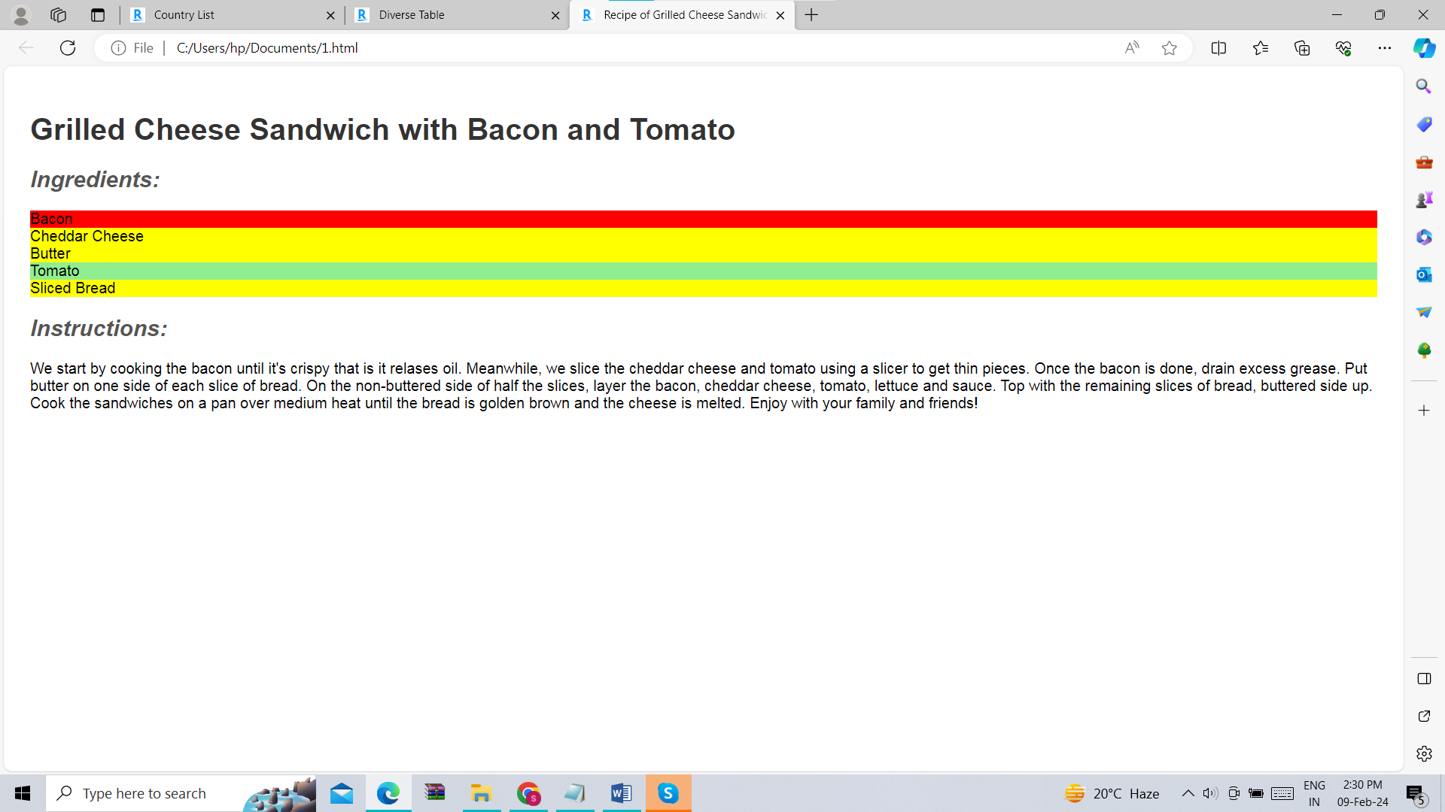

T4.

<!DOCTYPE html>

<html lang="en">

<head>

<meta charset="UTF-8">

<meta name="viewport" content="width=device-width, initial-scale=1.0">

<style>

body {

margin: 0;

font-family: 'Roboto', sans-serif;

overflow: hidden;

}

.container {

display: flex;

width: 100%;

}

.column {

flex: 1;

height: 100vh;

overflow: auto;

}

.left-column {

background-color: #d3d3d3;

}

.right-column {

background-color: #90EE90;

}

ul {

padding: 0;

list-style: none;

}

li {

margin-bottom: 10px;

}

</style>

<title>Books and Celebrities</title>

</head>

<body>

<div class="container">

<div class="column left-column">

<h2>Best Selling Books on Kindle</h2>

<ul>

<li>Shadow and Bone</li>

<li>Twilight</li>

<li>Harry Potter</li>

<li>Shadowhunters</li>

<li>The Hunger Games</li>

</ul>

</div>

<div class="column right-column">

<h2>Favorite Celebrities/Athletes</h2>

<ul>

<li>Taylor Swift</li>

<li>Kim Jennie</li>

<li>Blake lively</li>

<li>Elizabeth Olsen</li>

<li>Gal Gadot</li>

</ul>

</div>

</div>

</body>

</html>

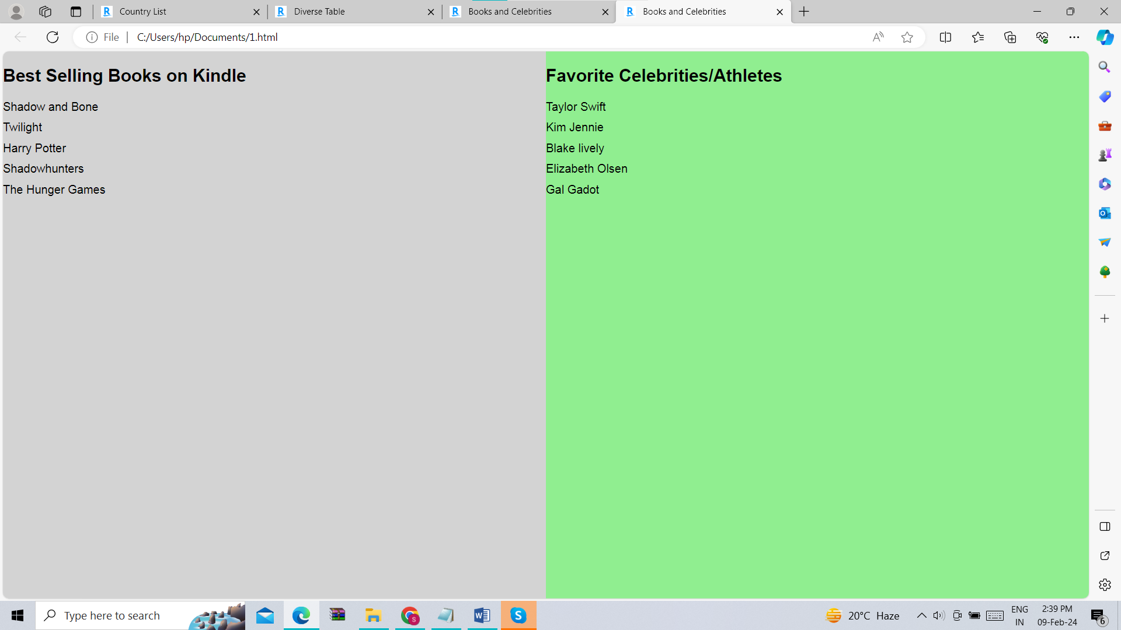

T5.

<!DOCTYPE html>

<html lang="en">

<head>

<meta charset="UTF-8">

<meta name="viewport" content="width=device-width, initial-scale=1.0">

<style>

body {

margin: 0;

font-family: 'Arial', sans-serif;

}

nav {

background-color: #0000FF;

padding: 10px;

text-align: center;

}

nav h1 {

margin: 0;

color: #00008B;

transition: background-color 0.3s ease;

}

nav h1:hover {

background-color: #00008B;

color: #fff;

}

ul {

list-style: none;

padding: 0;

margin: 0;

}

li {

display: inline;

margin-right: 20px;

}

a {

text-decoration: none;

color: #333;

}

</style>

<title>Navbar with Hover Effect</title>

</head>

<body>

<nav>

<h1>Resume</h1>

<ul>

<li><a href="#">Home</a></li>

<li><a href="#">About Us</a></li>

<li><a href="#">Contact</a></li>

</ul>

</nav>

This webpage is dedicated to create Resumes for people who want it to be made professionally.

</body>

</html>

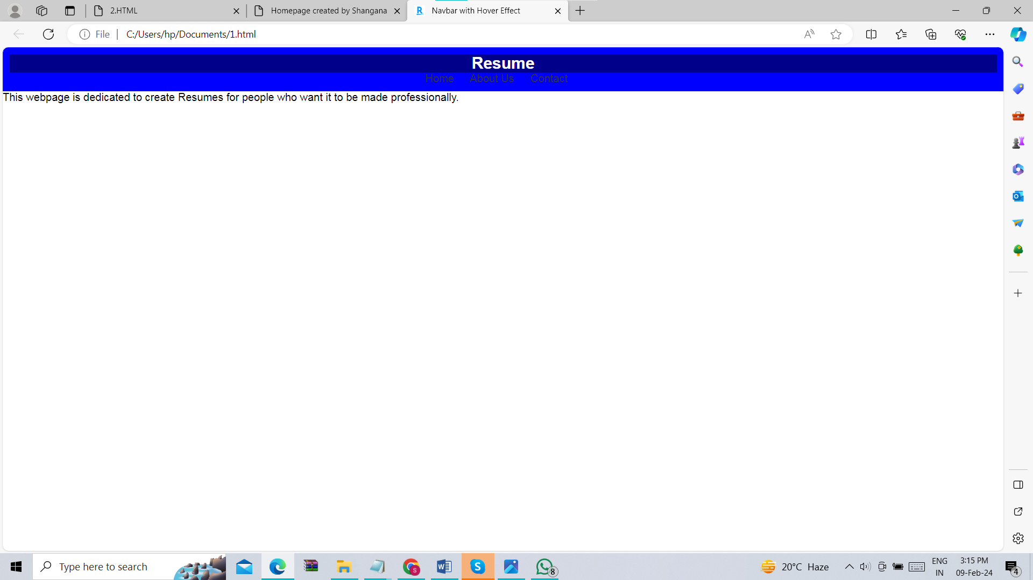

T6.

<!DOCTYPE html>

<html lang="en">

<head>

<meta charset="UTF-8">

<meta name="viewport" content="width=device-width, initial-scale=1.0">

<style>

@keyframes spin {

0% { transform: rotate(0deg); }

100% { transform: rotate(360deg); }

}

img {

width: 500px;

animation: spin 2s linear infinite;

}

</style>

<title>Spin Animation of a Playing Card</title>

</head>

<body>

<img src="C:\Users\hp\Downloads\CARDS.webp" alt="Playing Card">

</body>

</html>

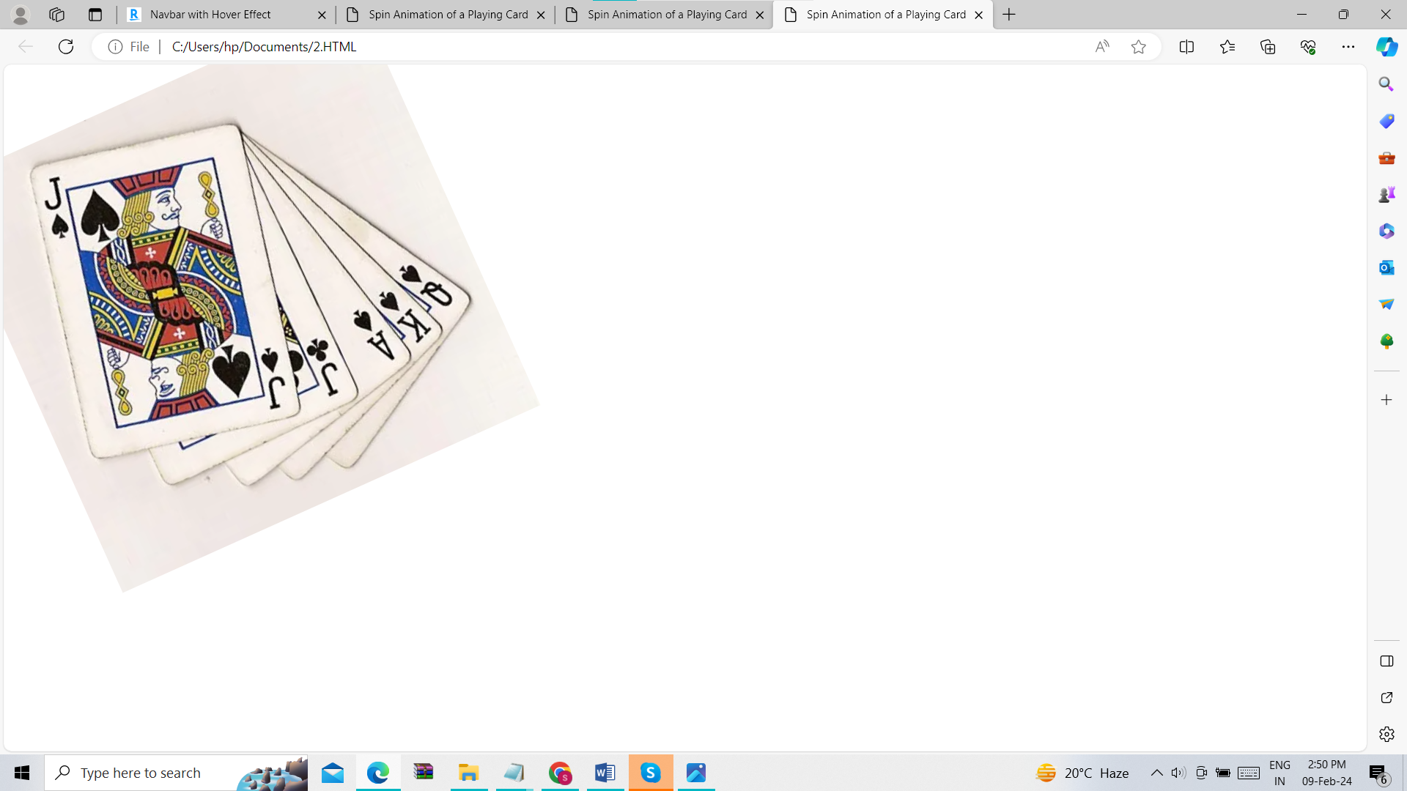

T7.

The link is also included in the code -<https://github.com/Shangana-Yadav/hobbies.html>

<!DOCTYPE html>

<html lang="en">

<head>

<meta charset="UTF-8">

<meta name="viewport" content="width=device-width, initial-scale=1.0">

<link rel="stylesheet" href="styles.css">

<title>Homepage created by Shangana</title>

</head>

<style>

body {

margin: 0;

font-family: 'Roboto', sans-serif;

}

header {

background-color: #333;

color: #fff;

padding: 10px;

position: fixed;

width: 100%;

top: 0;

}

nav ul {

list-style: none;

padding: 0;

margin: 0;

display: flex;

}

nav li {

margin-right: 20px;

}

nav a {

text-decoration: none;

color: #fff;

font-weight: bold;

}

.container {

display: flex;

padding-top: 60px; /\* Adjust to match the height of the fixed navbar \*/

}

.main-content {

flex: 1;

padding: 20px;

}

aside {

width: 300px;

background-color: #eee;

padding: 20px;

}

footer {

background-color: #333;

color: #fff;

padding: 10px;

text-align: center;

position: fixed;

width: 100%;

bottom: 0;

}

</style>

<body>

<header>

<nav>

<ul>

<li><a href="index.html">Home Page</a></li>

<li><a href="hobbies.html">Hobbies</a></li>

<li><a href="teams.html">Favorite Teams</a></li>

</ul>

</nav>

</header>

<div class="container">

<div class="main-content">

<h1>Welcome to My Homepage</h1>

<p>Thank you very much for visiting my homepage.</p>

</div>

<aside>

<h2>About Me</h2>

<p>My name is Shangana Yadav. I am enrolled in a Btech program in RGIPT majoring in Information Technology. I live in Lucknow.</p>

</aside>

</div>

<footer>

<p>2024 Shangana. All rights are reserved.</p>

</footer>

</body>

</html>

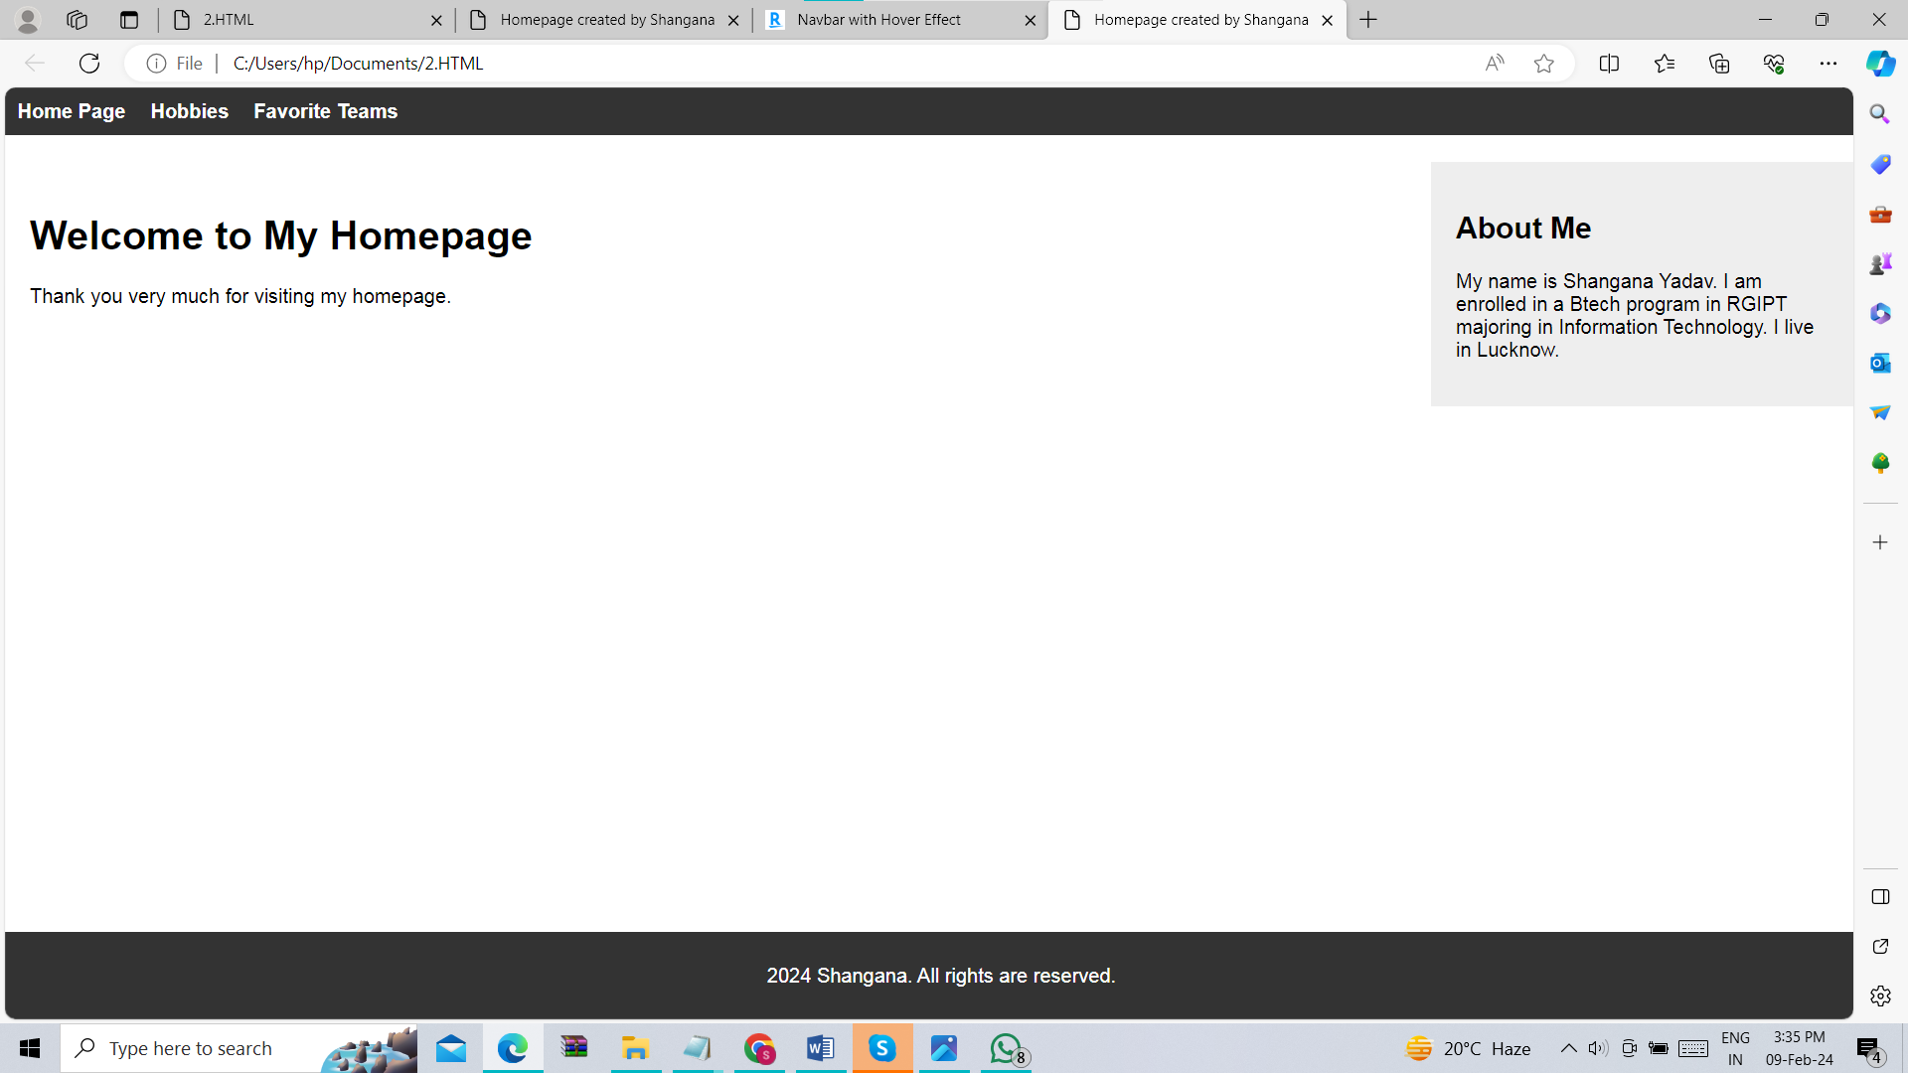

T8.

<!DOCTYPE html>

<html lang="en">

<head>

<meta charset="UTF-8">

<meta name="viewport" content="width=device-width, initial-scale=1.0">

<style>

body {

margin: 0;

font-family: 'Arial', sans-serif;

overflow: hidden;

}

.menu {

list-style: none;

padding: 0;

margin: 0;

display: flex;

}

.menu li {

position: relative;

margin-right: 20px;

}

.menu a {

text-decoration: none;

color: #333;

font-weight: bold;

padding: 10px;

display: block;

}

.submenu {

display: none;

position: absolute;

top: 100%;

left: 0;

background-color: #eee;

box-shadow: 0 2px 4px rgba(0, 0, 0, 0.1);

}

.menu li:hover .submenu {

display: block;

}

.submenu li {

margin: 0;

}

.submenu a {

padding: 10px;

display: block;

}

</style>

</head>

<body>

<ul class="menu">

<li><a href="#">Home Page</a></li>

<li>

<a href="#">Various Categories</a>

<ul class="submenu">

<li><a href="#">Books</a></li>

<li><a href="#">Food</a></li>

<li><a href="#">Places</a></li>

</ul>

</li>

<li><a href="#">About Us</a></li>

<li>

<a href="#">Contact Through</a>

<ul class="submenu">

<li><a href="#">Email</a></li>

<li><a href="#">Phone</a></li>

</ul>

</li>

</ul>

</body>

</html>

